Full Name: Rakyan Satrya Adhikara

Student ID: 219548135

SIT210 Task 11.2P

* Overview
  + Background
    - Doorbells are useful these days. It’s better for remind people in the house that someone’s wanting to go inside, have a chat or two. There are varieties of doorbells that are being used, from traditional doorbells or even to smart doorbells that included live feed. However, not everyone can use that, especially those who have disability, and not all modern doorbells have enough benefits. Plus, different smart doorbell requires different application.
  + Problem Statement
    - Not all doorbells, either traditional or modern, can be used by anyone (I.e. people who have disability)
    - Not all modern doorbells have enough benefits
    - Different smart doorbell requires different application
  + Requirements
    - Hardware:
      * Raspberry Pi 3B+
      * Ultrasonic Sensor (HC-SR04)
      * PIR Infrared Sensor (HC-SR501)
      * 5MP Camera for Raspberry Pi
      * LED Lights
      * Jumper Wires (M-F)
      * Jumper Wire (M-M)
      * Breadboard
    - Software:
      * Raspbian
      * Python 3 IDE
* Design Principles:
  + Use direct electricity, can be set the energy with battery.
  + Prefer local, can be set all the images from cloud.
  + Make doorbell can be use by anyone, even for people who have disability.
  + Document everything.
  + don't over complicate
  + Make choices, which impose limitations, such as, limit languages to: bash, python3
  + All python and bash scripts must run stand alone
  + Only use necessary tools and frameworks
  + Always use lightweight tools
  + Follow best practices
  + Use sensors for better accuracy
* Prototype Architecture

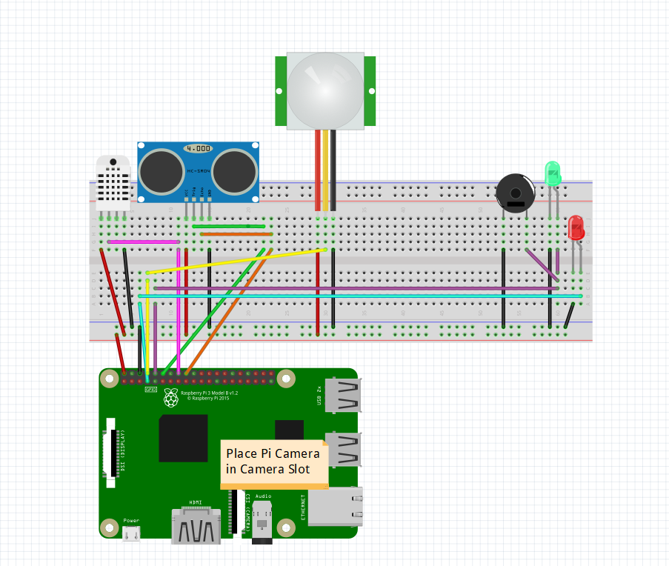

* Link to prototype code on Github:
  + <https://github.com/radhikara/SmartDoorbell.git>
* Testing approach you have used for evaluating your system
  + I test this program by:
    - For the ultrasonic, check if it can detect the distance
    - For the Infrared sensor, check if it can detect my motion
    - For the camera, check if it can capture me
* User Manual:
  + Get all the hardware and software requirements
  + Install Raspbian to the SD Card
  + Get the code by clone the repository from the GitHub
  + Connect the Pi Camera to the Camera slot
  + Connect all the cables according to the design
  + Install all necessary libraries that is being imported in the code
  + Run the code
* Conclusion:
  + In conclusion, my experience on this project was more than I expected. Not only there were some complication regarding on the software, but the hardware as well. Those complications such as the motion sensor did not detect any movement at the beginning, many codes that I had to reorganize regarding to those sensors. However, those complications are very helpful too. Since the motion sensor is very selective, meaning that it will be only a person can be detected by that sensor.
  + If I had second chance to do this project, I would have connected the Raspberry Pi to more microprocessors, such as Arduino or Particle device, I would have configured more on sending to the cloud and I would have done in better designing.